VINSUP SKILL ACADEMY
Coimbatore - 641006

PROJECT DOCUMENTATION REPORT

Retail Sales Analytics Using Excel, SQL, Power BI and Python

Student Name | Anbarasu s
Institution | Vinsup Skill Academy
Domain | Retail, Sales & Inventory Analytics
Tools Used | Excel | MySQL | Python | Power BI
Submission Date | April 2026

Dashboard Link
Project Drive Folder:
The project folder contains all deliverables including SQL scripts, Python notebook, Power BI dashboard (.pbix), and segmentation output CSV.

INTRODUCTION

Introduction to Business Problems Retail businesses face multiple
operational and analytical challenges due to large volumes of
transactional and inventory data. Without proper analysis, these problems
lead to revenue loss, poor customer retention, and inefficient inventory
management .This section identifies key retail problems and explains how
data analysis helps solve them.

Phase 1: Project overview

This project focuses on analyzing retail sales data by building a
complete data pipeline from raw Excel files to an interactive Power BI
dashboard. The objective is to clean, transform, and analyze the data
to generate meaningful business insights and customer
segmentation.

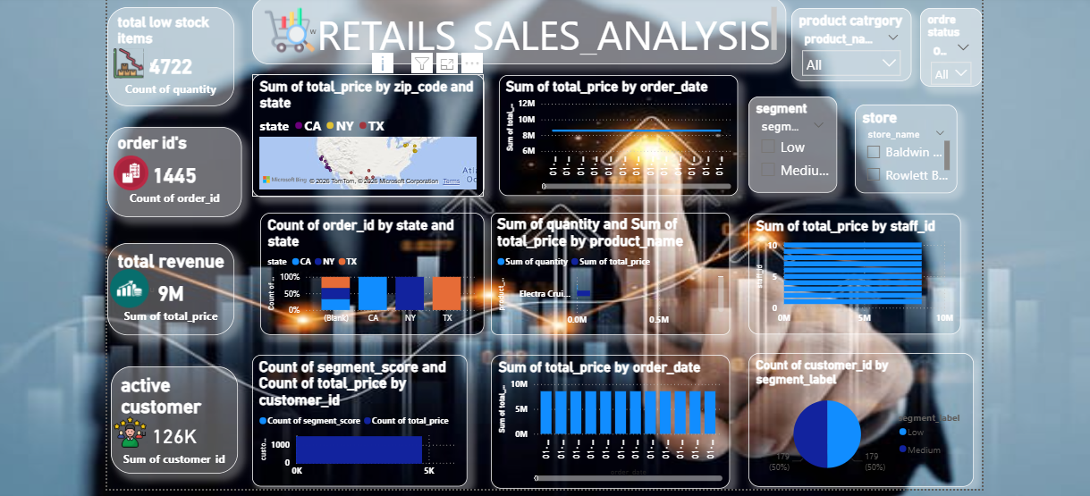

Phase 3: Problem statement

Organizations often struggle to extract actionable insights from raw
data. This project addresses the following challenges:- Unstructured
and inconsistent data- Lack of centralized database- Difficulty in
identifying customer behavior patterns- Limited visibility into sales and
inventory performance

Phase 4: Key Business Problems

*Lack of Customer Insights :
*Businesses do not clearly understand customer behavior
*Difficult to identify loyal vs inactive customers
*No segmentation for targeted marketing

*Solution :
*Applied RFM (Recency, Frequency, Monetary) analysis
*Used clustering (K-Means) to segment customers

Phase 5: Poor Sales Performance Visibility

* No clear view of total revenue trends
* Difficult to identify top-performing products
*Lack of monthly/seasonal analysis

Solution :
*Created sales trend analysis (daily/monthly/yearly)
*Built KPIs such as Total Revenue and Average Order Value
Phase 6 Inventory Management Issues-

*Overstocking or understocking products
* No alerts for low stock items
* Inefficient stock distribution across stores
Solution :
*Analyzed stock levels using stocks table
*Created low-stock alerts (threshold-based)
*Compared stock vs sales performance

Phase 7: Data Quality Issues

*Missing values (ZIP codes, dates)
* Duplicate records
*inconsistent formats
Solution :
*Data cleaning in Excel
* Standardized formats-
*Validated foreign key relationships

Phase 8: Inefficient Decision-Making-

*Decisions based on assumptions, not data
* No centralized reporting system
Solution :
* Built Power BI dashboards
*Enabled real-time insights using visuals
*Provided interactive filtering (slicers)

Phase 9: Lack of Staff & Store Performance Analysis

* No clarity on which store performs better-
* Staff productivity not tracked
Solution :
* Analyzed revenue per store-
*Evaluated staff performance using order handling data

Phase 10: Exploratory Data Analysis

* Identified trends and patterns
* Compared categories and brands
*Detected anomalies

Phase 11: Business Impact

Before Analysis :
*Limited visibility
*Reactive decision-making
* Poor customer targeting

After Analysis :
* Data-driven decisions-
* Improved customer retention strategies-
*Better inventory planning-
*Increased operational efficiency

Phase 12: Recommendations

*Focus marketing on high-value customers
* Provide offers to at-risk customers
* Maintain optimal stock levels
*Monitor sales trends regularly
*Use dashboards for continuous decision-making

Phase 13: Conclusion

*Retail sales problems can be effectively solved using data
analytics techniques. By combining SQL, Python, and Power BI, this
project transforms raw data into actionable insights that improve
business performance and decision-making.

